Decision Trees – Recommending App to user based on their age and gender.

Naïve Bayes – Detecting Spam E-mails.

Gradient Descent – Reducing the error function until we find the minimum value.

Logistic Regression – Classifying data into two categories and separating them using a line.

Support Vector Machine – Maximizing the distance between the line separating two different data categories.

Neural Networks – Various nodes involved in decision making process getting input from one and outputting the decision.

Kernel Method –

K-Means Clustering – Clustering data to n numbers of clusters.

Hierarchical Clustering – Used when number of cluster is not know but the distance separating them is known.

**Confusion Matrix:**

|  |  |  |
| --- | --- | --- |
|  | **Diagnosed Sick** | **Diagnosed Healthy** |
| **Sick** | **True Positive** | **False Negative** |
| **Healthy** | **False Positive** | **True Negative** |

**Accuracy = Correctly Classified Points (True Positives + True Negative)/ Total Number of points.**

**Recall/Precision:**

**Precision:** Out of the patients we diagnosed with an illness, how many did we classify correctly?

**Recall:** Out of the sick patients, how many did we correctly diagnose as sick?

**Combining these two scores in one:**

**Harmonic Mean or F1 Score: 2*((Precision*Recall)/(Precision + Recall))**

**F-beta Score:**

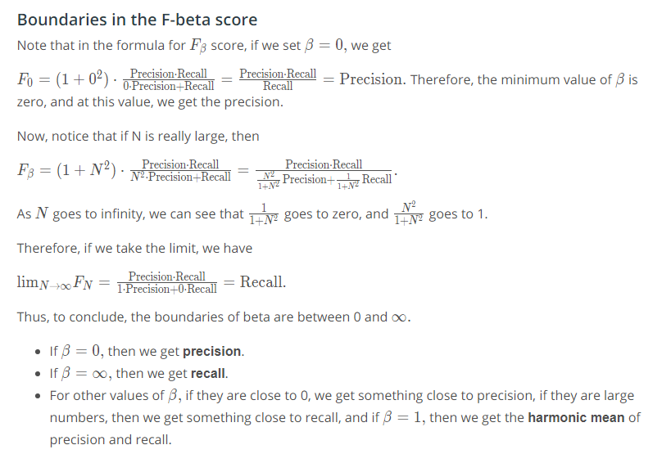

**Receiver Operating Characteristic (ROC):**

* Bias is error due to erroneous or overly simplistic assumptions in the learning algorithm you are using. Bias is often the cause of underfitting.